**Internship Report: Advanced Data Analytics Dashboard**

**1. Introduction**

During my internship at NullClass, I had the opportunity to develop an Advanced Data Analytics Dashboard for portfolio management. This web-based application simulates stock market data, provides real-time analytics, and helps users track their investments using various technical indicators. The goal was to create a user-friendly financial tool that offers interactive features for better investment decision-making.

**2. Background**

Analyzing financial data effectively requires powerful visualization tools that highlight market trends and key metrics. While many existing dashboards lack customization and real-time simulation, this project aimed to fill that gap by incorporating:

* Simulated Stock Data: Using randomized data to mimic market behavior.
* Interactive Visualizations: Built with Chart.js for dynamic financial charts.
* Technical Indicators: Including SMA (Simple Moving Average), EMA (Exponential Moving Average), RSI (Relative Strength Index), and Volatility Calculation.
* User Authentication & Portfolio Tracking: Allowing users to manage their portfolios with simulated trading.

**3. Learning Objectives**

The main objectives of this project were:

* Develop a responsive, full-stack web application using HTML, CSS, and JavaScript.
* Implement interactive data visualization using Chart.js.
* Apply financial concepts like SMA, EMA, RSI, and volatility calculations.
* Build a simple user authentication system for login and signup.
* Simulate real-time stock data updates using randomized algorithms.

**4. Activities and Tasks**

**Key Features Implemented**

**Stock Data Simulation**

* Generated random prices for 14 major stocks (e.g., AAPL, GOOGL).
* Tracked historical price data for trend analysis.

**Technical Indicators**

* SMA (Simple Moving Average) for short-term trends.
* EMA (Exponential Moving Average) for long-term trends.
* RSI (Relative Strength Index) to gauge market momentum.
* Volatility Calculation to measure market fluctuations.

**Interactive Dashboard**

* Users can toggle indicators on and off for clearer analysis.
* Detailed stock charts with dynamic updates.
* Simulated buying and selling of stocks with portfolio management.

**User Management**

* Login and signup functionality using a simple authentication system.
* Portfolio tracking with simulated transactions.
* Transaction history for reviewing past trades.

**Responsive UI**

* Clean and mobile-friendly design with tab-based navigation.
* Adaptive charts and responsive layouts for all devices.

**5. Skills and Competencies Gained**

* Frontend Development: Enhanced skills in HTML5, CSS3, and JavaScript (ES6+).
* Data Visualization: Developed dynamic financial charts using Chart.js.
* Financial Analytics: Gained insights into financial indicators and their calculations.
* Authentication: Implemented basic login/signup systems using local data storage.
* Problem-Solving: Tackled debugging challenges and optimized real-time updates.

**6. Feedback and Evidence**

* Functional Prototype: Successfully developed a working prototype for stock market simulation.
* Code Quality: Organized code using modular JavaScript functions.
* User Testing: Basic authentication and portfolio tracking performed well.
* Visual Appeal: Clean UI with responsive design for easy navigation.

**7. Challenges and Solutions**

| **Challenge** | **Solution** |
| --- | --- |
| Real-time data updates | Used setInterval() for periodic updates. |
| RSI/Volatility Calculation | Implemented formulas using JavaScript. |
| Dynamic Chart Rendering | Configured Chart.js for smooth rendering. |
| User Session Management | Utilized LocalStorage for persistent data. |

**8. Outcomes and Impact**

* Developed a functional dashboard for simulated stock trading and data analysis.
* Enhanced my understanding of financial concepts and data visualization.
* Created a scalable application that can be further extended with real API integration.
* Gained valuable experience in full-stack development.

**9. Conclusion**

This internship project allowed me to apply both technical and financial knowledge in a practical scenario. The experience strengthened my web development skills while providing a deeper understanding of market analysis. Moving forward, potential enhancements could include:

* Integrating with real-time stock APIs (e.g., Alpha Vantage).
* Adding advanced backtesting features for deeper analysis.
* Supporting multiple users with backend data management.

**Appendices**

* **Screenshots of the Application:**

**Dashboard Page**

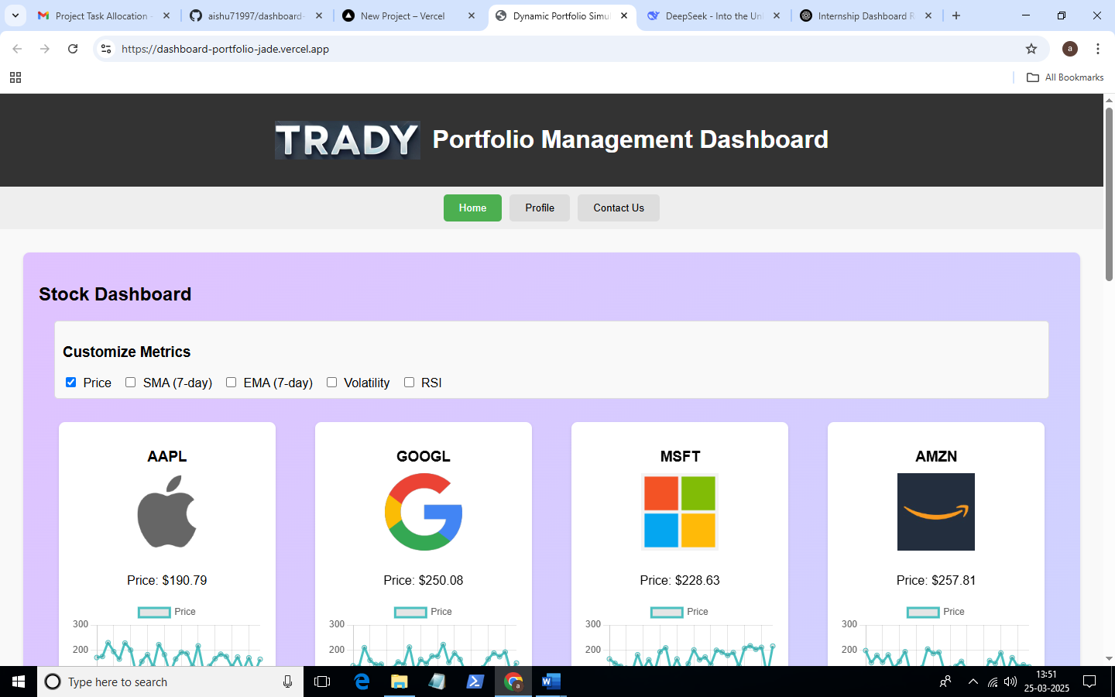

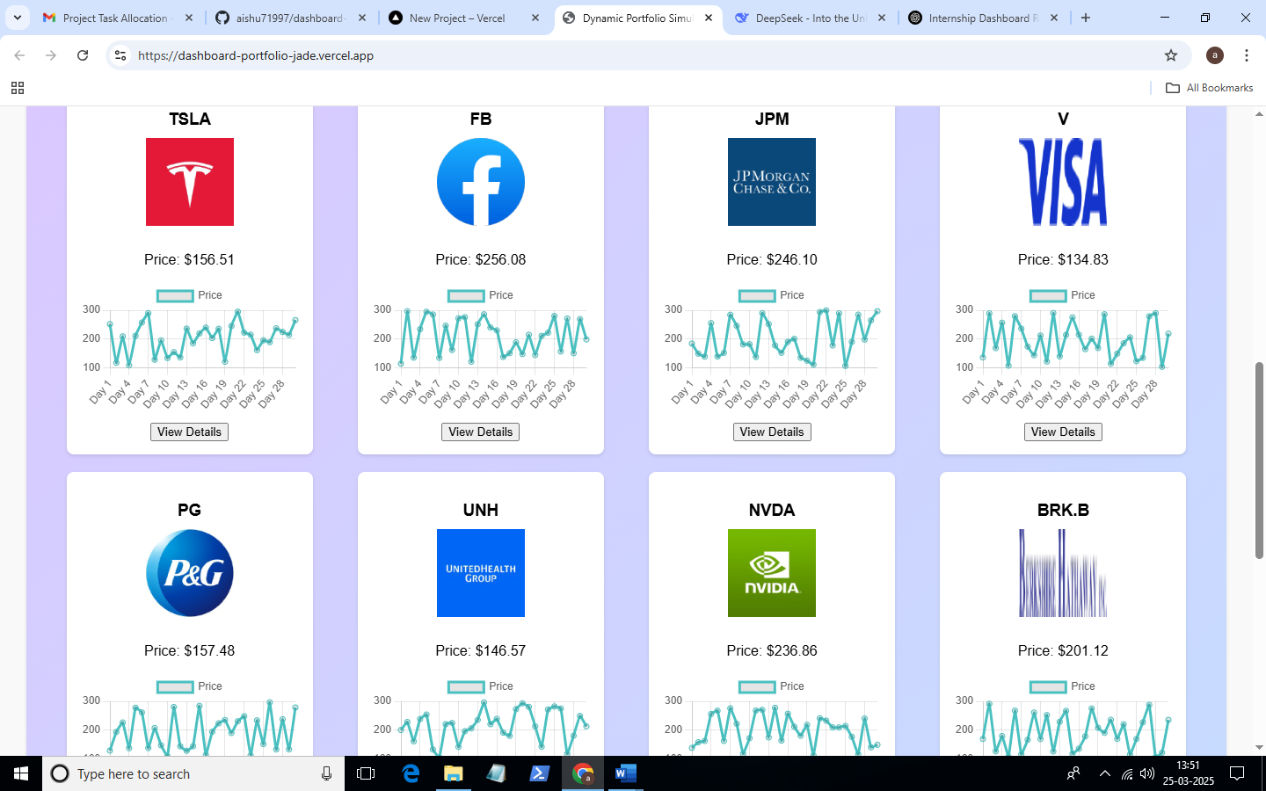

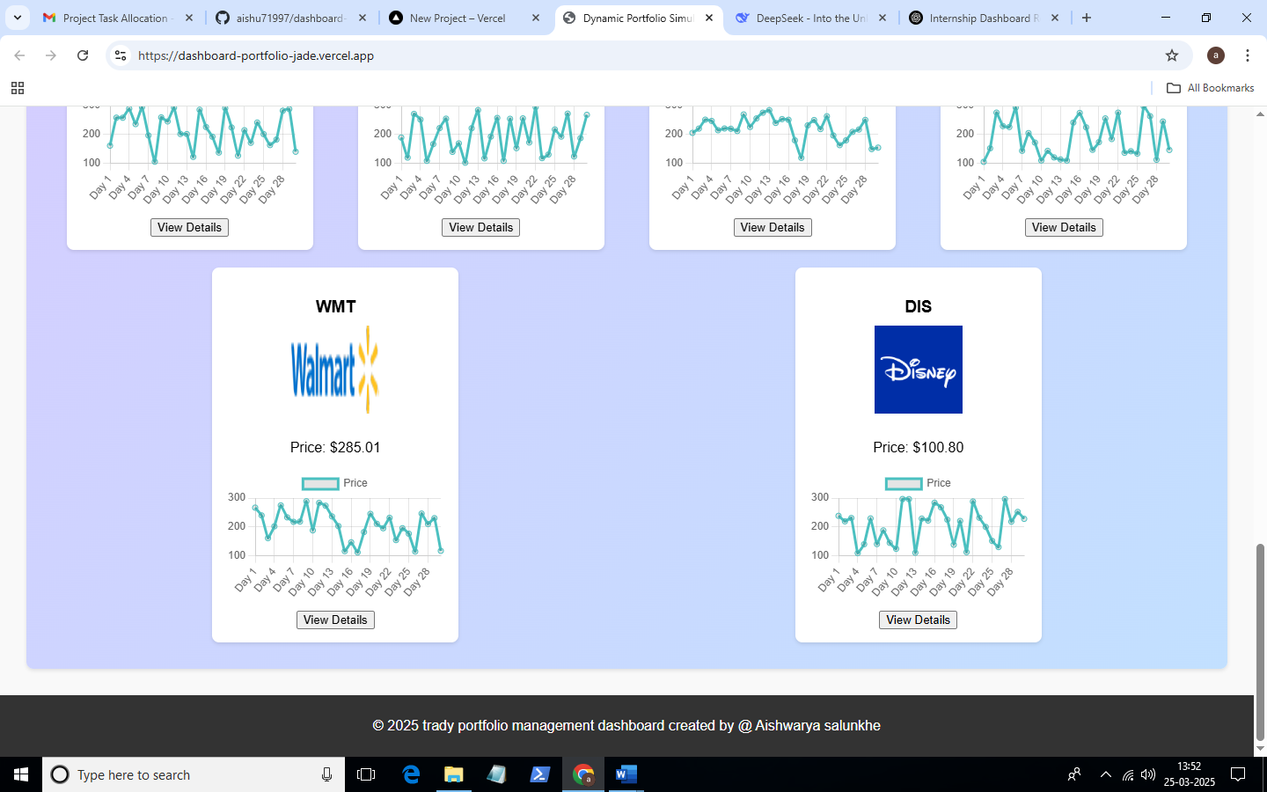

**Metrics Selection Panel**

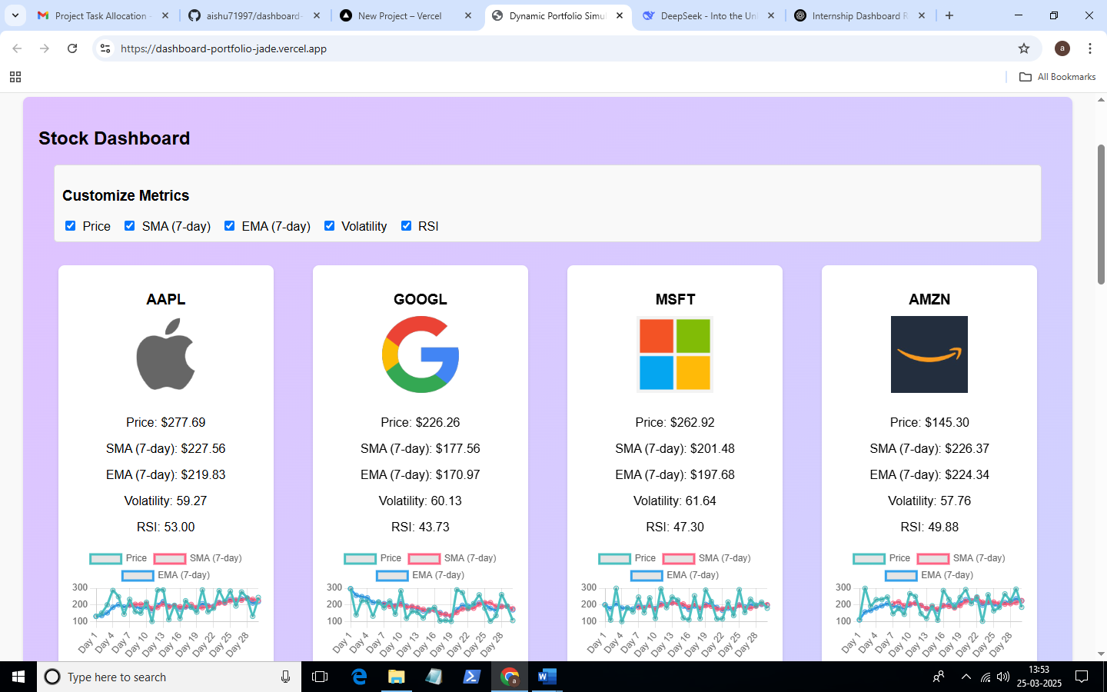

* + **Chart View with Static Data Simulation**

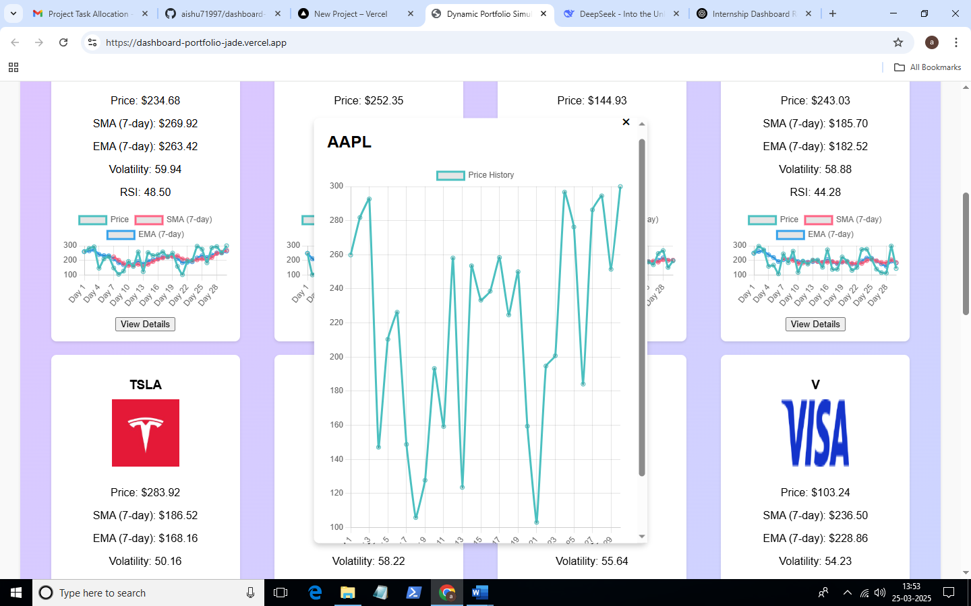

**Profile**

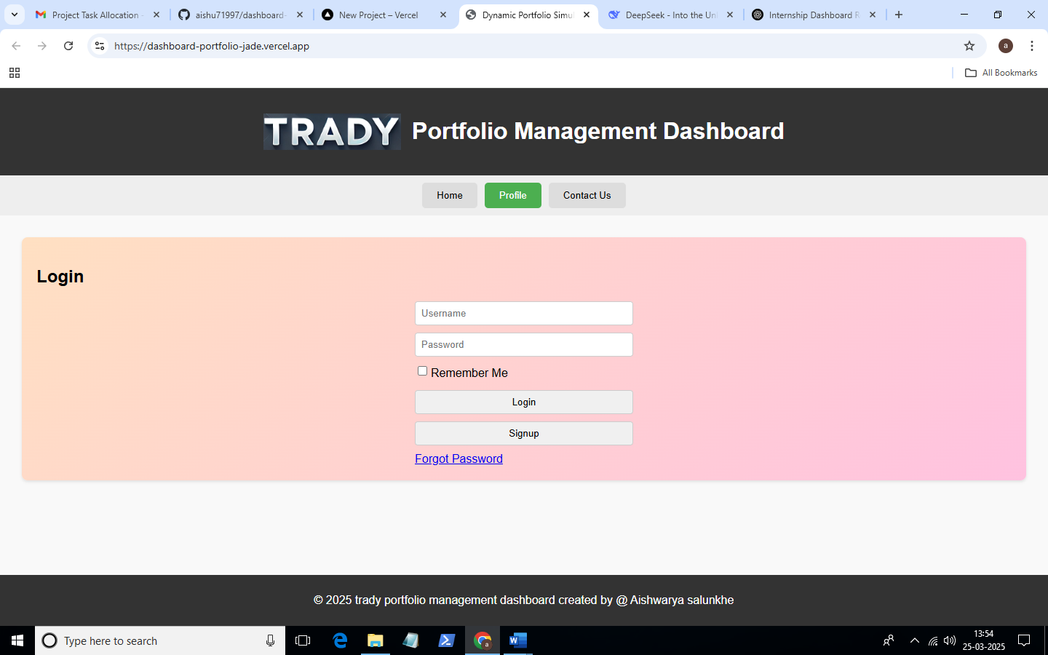

**My account**

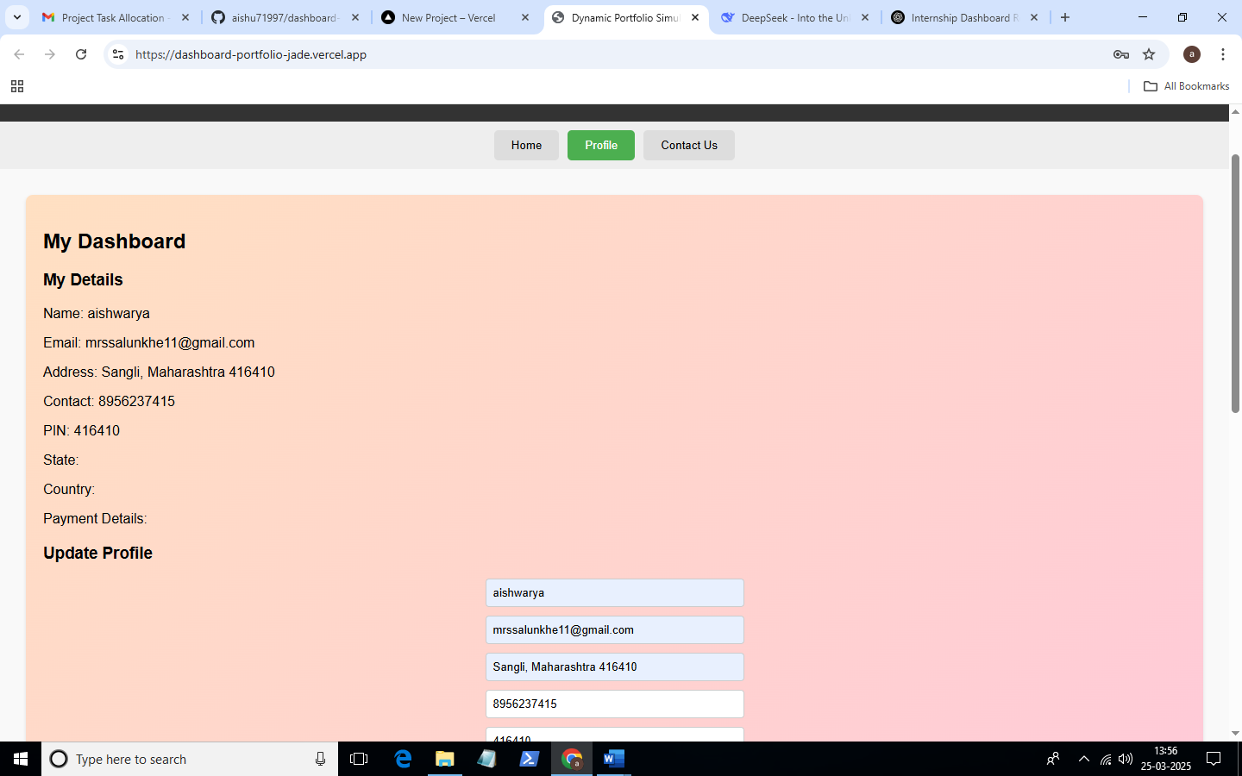

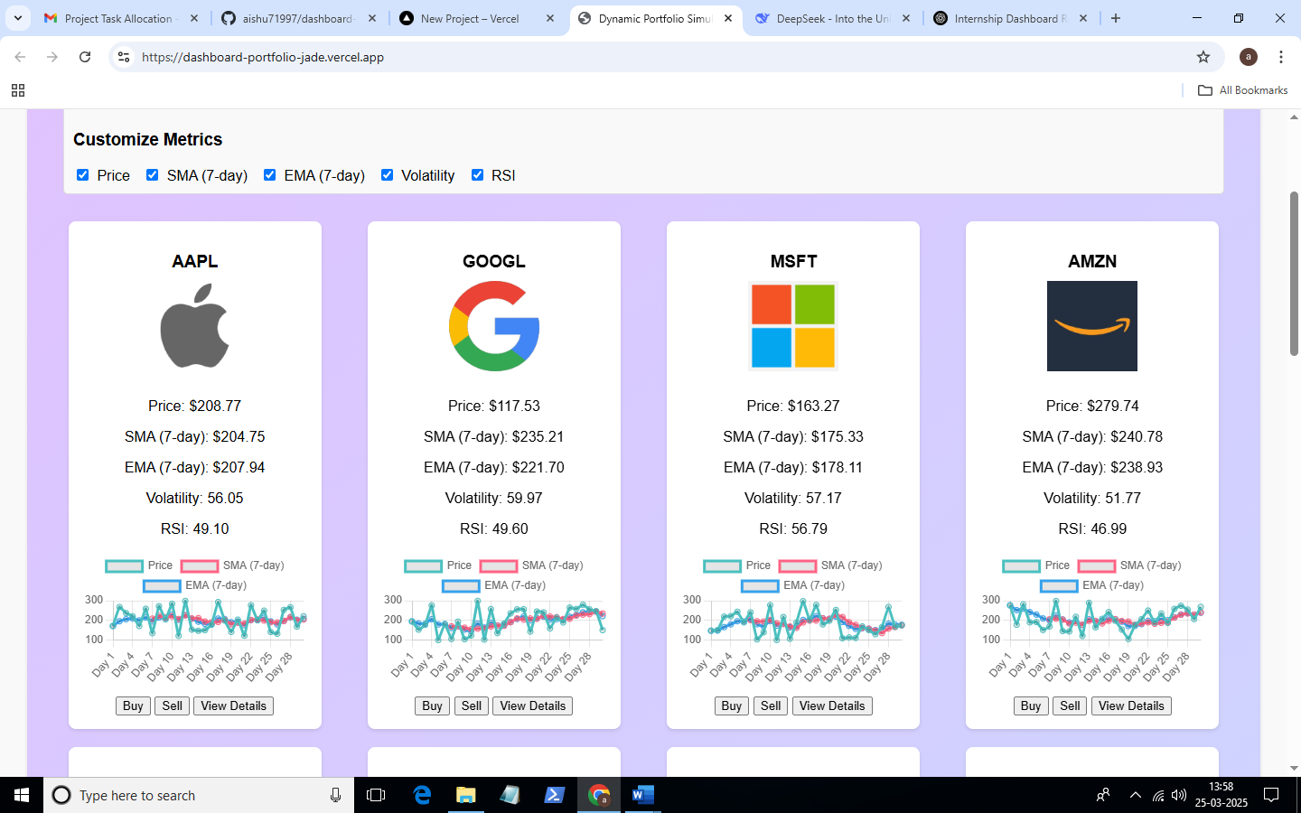

**Transection**

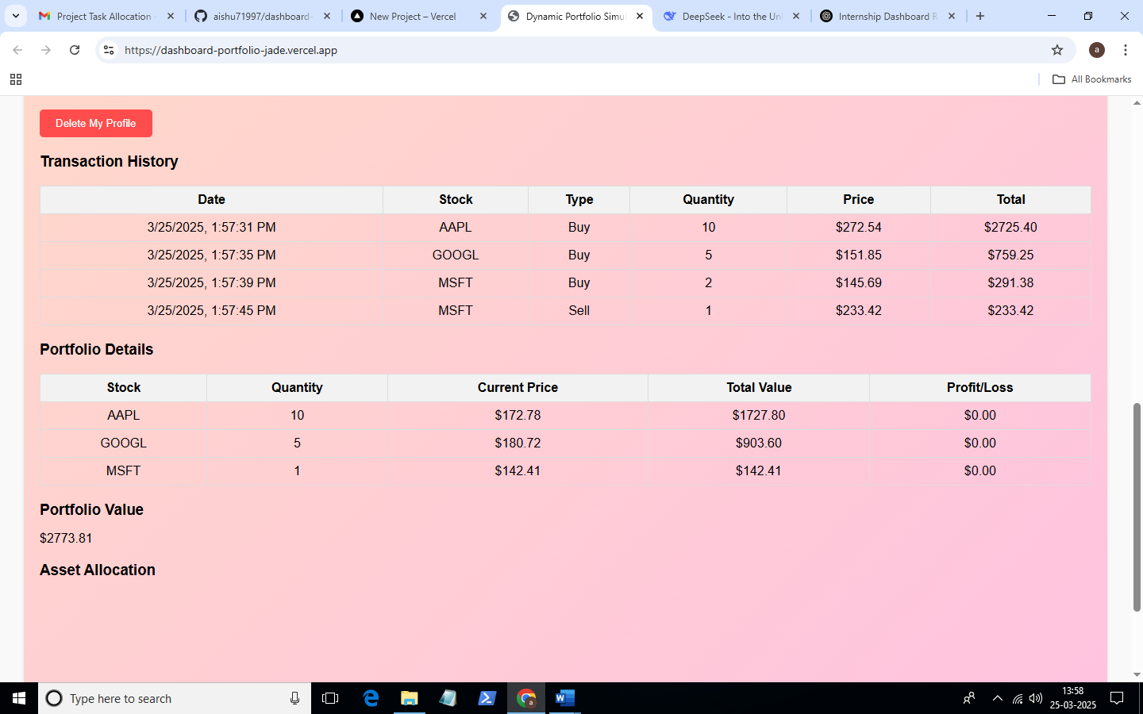

**Contact us**

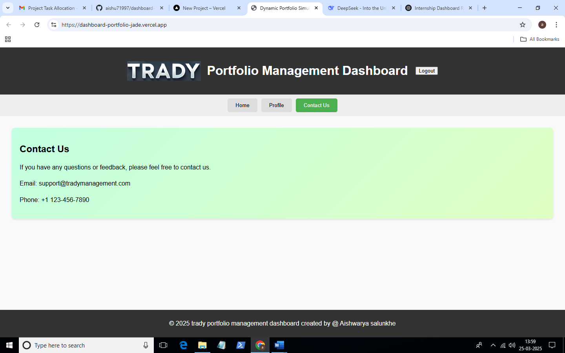

* **GitHub Repository:** [Repository](https://github.com/aishu71997/advance-dashboard)
* **Hosted Application Link:** <https://dashboard-portfolio-rho.vercel.app/>